CSCI 5010 – Fundamentals of Data Communications

Lab 6

Wireshark

University of Colorado Boulder

Department of Computer Science

Network Engineering

Professor Levi Perigo, Ph.D.

# Objectives

* Learn the basic operations of Wireshark
* Learn how to capture and analyze ICMP traffic
* Demonstrate best practices for analyzer placement
* Differentiate Wireshark captures between switches and routers
* Display which NICs on analyzer are capturing traffic
* Display IPv4 and/or IPv6 addresses on NICs
* Learn how to perform continuous captures for HTTP requests
* Explain and display different ways to demonstrate top talkers on the network
* Learn how to create coloring rules in Wireshark
* Learn how to create graphs for visual representation
* Learn how to capture and analyze application specific traffic – DHCP, HTTP

# Summary

One’s understanding of network protocols can often be greatly deepened by “seeing protocols in action” and by “playing around with protocols” – observing the sequence of messages exchanged between two protocol entities, delving down into the details of protocol operation, and causing protocols to perform certain actions and then observing these actions and their consequences. This can be done in simulated scenarios or in a “real” network environment such as the Internet. In the Wireshark lab you’ll be doing in this course, you’ll be running various network applications in different scenarios using your own computer or in a virtual machine environment. You’ll observe the network protocols “in action,” interacting and exchanging messages with protocol entities executing elsewhere in the Internet. Thus, you and your computer will be an integral part of these “live” labs. You’ll observe, and you’ll learn, by doing.

In this Wireshark lab, you’ll get acquainted with Wireshark, and make some simple packet captures and observations.

The basic tool for observing the messages exchanged between executing protocol entities is called a packet sniffer. As the name suggests, a packet sniffer captures (“sniffs”) messages being sent/received from/by your computer; it will also typically store and/or display the contents of the various protocol fields in these captured messages. A packet sniffer itself is passive. It observes messages being sent and received by applications and protocols running on your computer, but never sends packets itself. Similarly, received packets are never explicitly addressed to the packet sniffer. Instead, a packet sniffer receives a copy of packets that are sent/received from/by application and protocols executing on your machine. The packet capture library receives a copy of every link-layer frame that is sent from or received by your computer.

The second component of a packet sniffer is the packet analyzer, which displays the contents of all fields within a protocol message. In order to do so, the packet analyzer must “understand” the structure of all messages exchanged by protocols. For example, suppose we are interested in displaying the various fields in messages exchanged by the HTTP protocol. The packet analyzer understands the format of Ethernet frames, and so can identify the IP datagram within an Ethernet frame. It also understands the IP datagram format, so that it can extract the TCP segment within the IP datagram. Finally, it understands the TCP segment structure, so it can extract the HTTP message contained in the TCP segment. Finally, it understands the HTTP protocol and so, for example, knows that the first bytes of an HTTP message will contain the string “GET,” “POST,” or “HEAD.”

[We will be using the Wireshark packet sniffer [http://www.wireshark.org/](http://www.wireshark.org/)] for this lab, allowing us to display the contents of messages being sent/received from/by protocols at different levels of the protocol stack. (Technically speaking, Wireshark is a packet analyzer that uses a packet capture library in your computer). Wireshark is a free network protocol analyzer that runs on Windows, Linux/Unix, and Mac computers.

Prefer using VM1 - UBUNTU – 22.04

Part 1

Objective 1.1 - Downloading Wireshark and Navigation Overview

1. Download and install Wireshark:

For Ubuntu 22.04 refer - [How to Install and Configure Wireshark on Ubuntu 22.04 (linuxhint.com)](https://linuxhint.com/install-configure-wireshark-ubuntu-22-04/)

For Windows and MAC:

• Go to <http://www.wireshark.org/download.html>, download and install Wireshark.

• The Wireshark FAQ has many helpful hints and interesting tidbits of information, particularly if you have trouble installing or running Wireshark.

• Helpful install video: <https://www.youtube.com/watch?v=flDzURAm8wQ>

2. Wireshark Navigation

Helpful navigation video: <https://www.youtube.com/watch?v=PYrCS21sPbA>

Note: after installing you might need to reboot once.

# Objective 1.2 - Running Wireshark

When you run the Wireshark program, you’ll get a startup screen, as shown below (note: this screenshot may be an older version of Wireshark):

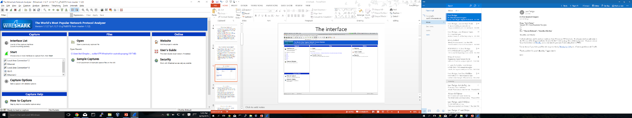

**Figure 1:** Initial Wireshark Screen

Take a look at the upper left-hand side of the screen – you’ll see an “Interface list”. This is the list of network interfaces on your computer. Once you choose an interface, Wireshark will capture all packets on that interface. In the example above, there is an Ethernet interface (Gigabit network connection) and a wireless interface (“Wi-Fi”).

If you click on one of these interfaces to start packet capture (i.e., for Wireshark to begin capturing all packets being sent to/from that interface), a screen like the one below will be displayed, showing information about the packets being captured. Once you start packet capture, you can stop it by using the Capture pull down menu and selecting Stop.

**command**

menus

display filter specification

**listing** of captured packets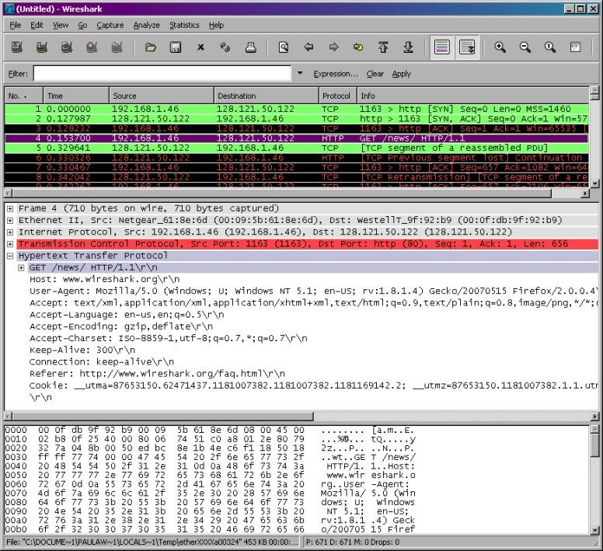

**details** of selected packet header

packet **content** in hexadecimal and ASCII

**Figure 2:** Wireshark Graphical User Interface, during packet capture and analysis

The Wireshark interface has five major components:

• The **command menus** are standard pulldown menus located at the top of the window. Of interest to us now are the File and Capture menus. The File menu allows you to save captured packet data or open a file containing previously captured packet data and exit the Wireshark application. The Capture menu allows you to begin packet capture.

• The **packet-listing window** displays a one-line summary for each packet captured, including the packet number (assigned by Wireshark; this is *not* a packet number contained in any protocol’s header), the time at which the packet was captured, the packet’s source and destination addresses, the protocol type, and protocol-specific information contained in the packet. The packet listing can be sorted according to any of these categories by clicking on a column name. The protocol type field lists the highest-level protocol that sent or received this packet, i.e., the protocol that is the source or ultimate sink for this packet.

• The **packet-header details window** provides details about the packet selected (highlighted) in the packet-listing window. (To select a packet in the packet- listing window, place the cursor over the packet’s one-line summary in the packet-listing window and click with the left mouse button.). These details include information about the Ethernet frame (assuming the packet was sent/received over an Ethernet interface) and IP datagram that contains this packet. The amount of Ethernet and IP-layer detail displayed can be expanded or minimized by clicking on the plus minus boxes to the left of the Ethernet frame or IP datagram line in the packet details window. If the packet has been carried over TCP or UDP, TCP or UDP details will also be displayed, which can similarly be expanded or minimized. Finally, details about the highest-level protocol that sent or received this packet are also provided.

• The **packet-contents window** displays the entire contents of the captured frame, in both ASCII and hexadecimal format.

• Towards the top of the Wireshark graphical user interface, is the **packet display filter field,** into which a protocol name or other information can be entered in order to filter the information displayed in the packet-listing window (and hence the packet-header and packet-contents windows). In the example below, we’ll use the packet-display filter field to have Wireshark hide (not display) packets except those that correspond to HTTP messages.

# Part 2

# Objective 2.1 – ICMP

1. Open command prompt/terminal (depending on the operating system)
2. Start Wireshark and begin capture
3. Ping any “hostname” (where the “hostname” is a URL, example: ping [www.google.com](http://www.google.com))
4. When the Ping finishes, stop the capture. [Press Ctrl + C in MAC to stop the ping]
5. Filter the capture to only display DNS traffic
   1. Provide a screenshot of the DNS reply from the server that shows the IP address of the URL. [**5 points**]

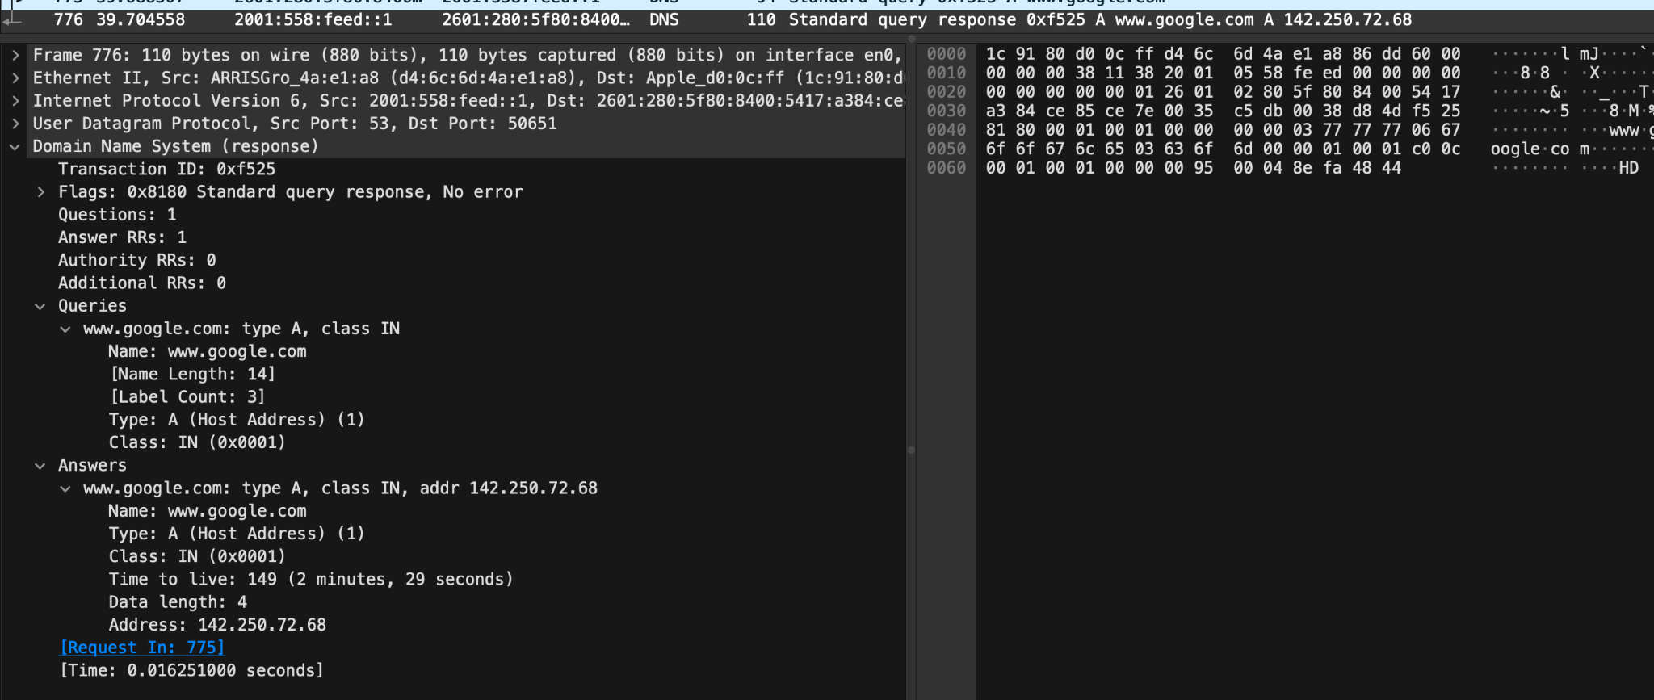

* 1. Explain why DNS would be in this capture when you pinged? [**5 points**]

DNS servers serve the purpose of converting domain names into IP addresses, as machines primarily comprehend binary code. So, when we attempt to ping "google.com," it must be converted into an IP address to make sense to our machine. Consequently, when we ping "google.com," the initial step involves making a request to the DNS server to fetch the IP address associated with "google.com" before proceeding to ping that IP address.

1. Filter the capture to only display the Ping traffic
   1. Were the Pings successful?

Yes, the pings were successful.

* 1. Provide the filtered Wireshark screenshot, and explain how you know they were/were not successful? [**10 points**]

As per the provided screenshot, it's apparent that the ping operations were successful. The "info" section in the capture indicates that each ICMP ping request was met with a corresponding ping reply. Additionally, it's noteworthy that the "seq" number in a ping request matches the "seq" number in the corresponding ping response. For instance, the first ping request has a "seq" of 0/0, and the response also carries a "seq" of 0/0, ensuring that the response corresponds to the original ping request. This pattern continues, where a ping request with a "seq" of 1/256 is followed by a ping response with the same "seq" of 1/256.

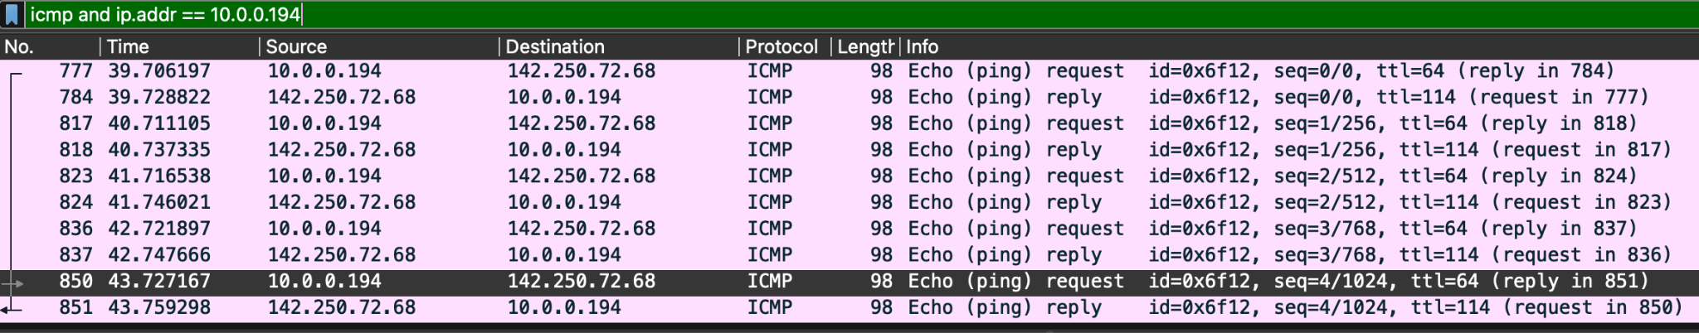

1. What is the IP address of your host? (show within Wireshark) [**5 points**]

The IP address of my laptop is 10.0.0.194

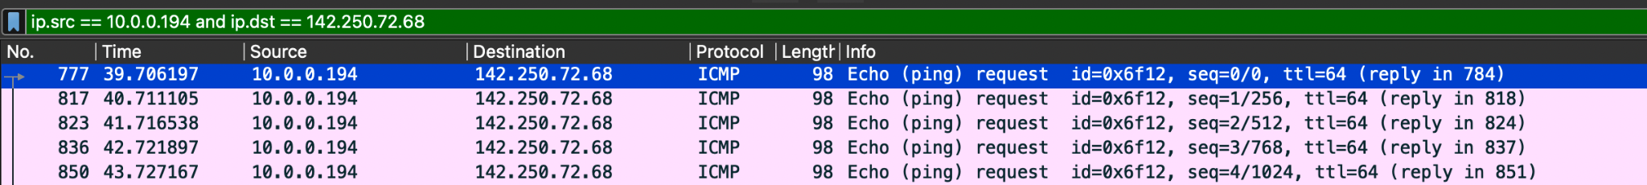

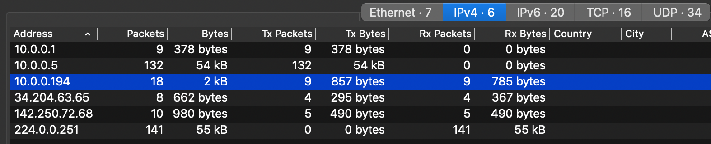

1. What is the IP address of the destination host?

The IP address of the destination host is 142.250.72.68.

* 1. Show within Wireshark, and explain how this address was selected? [**10 points**]



The address was selected via DNS (Domain Name Server). The process is as follows:

1. To resolve google.com’s IP address, the host first halts the ping process and sends a DNS query to the DNS server via the default gateway since the DNS server is not in the same network as the host. The source is an ipv6 address in my case (ending with ce85:ce7e) and the destination is the primary DNS server’s ipv6 address (ending with feed::1).
   1. In the "info" section, it is evident that this is a standard "query" designed to solicit an A record (the IPv4 address) for "www.google.com."
   2. Upon examining the headers, you'll notice that the source port takes on a random value, while the destination port is set to 53, which is the standard port utilized by DNS for communication.
   3. DNS operates over the User Datagram Protocol (UDP), as indicated in the provided screenshot, specifying "User Datagram Protocol" with a UDP destination port value of 53.

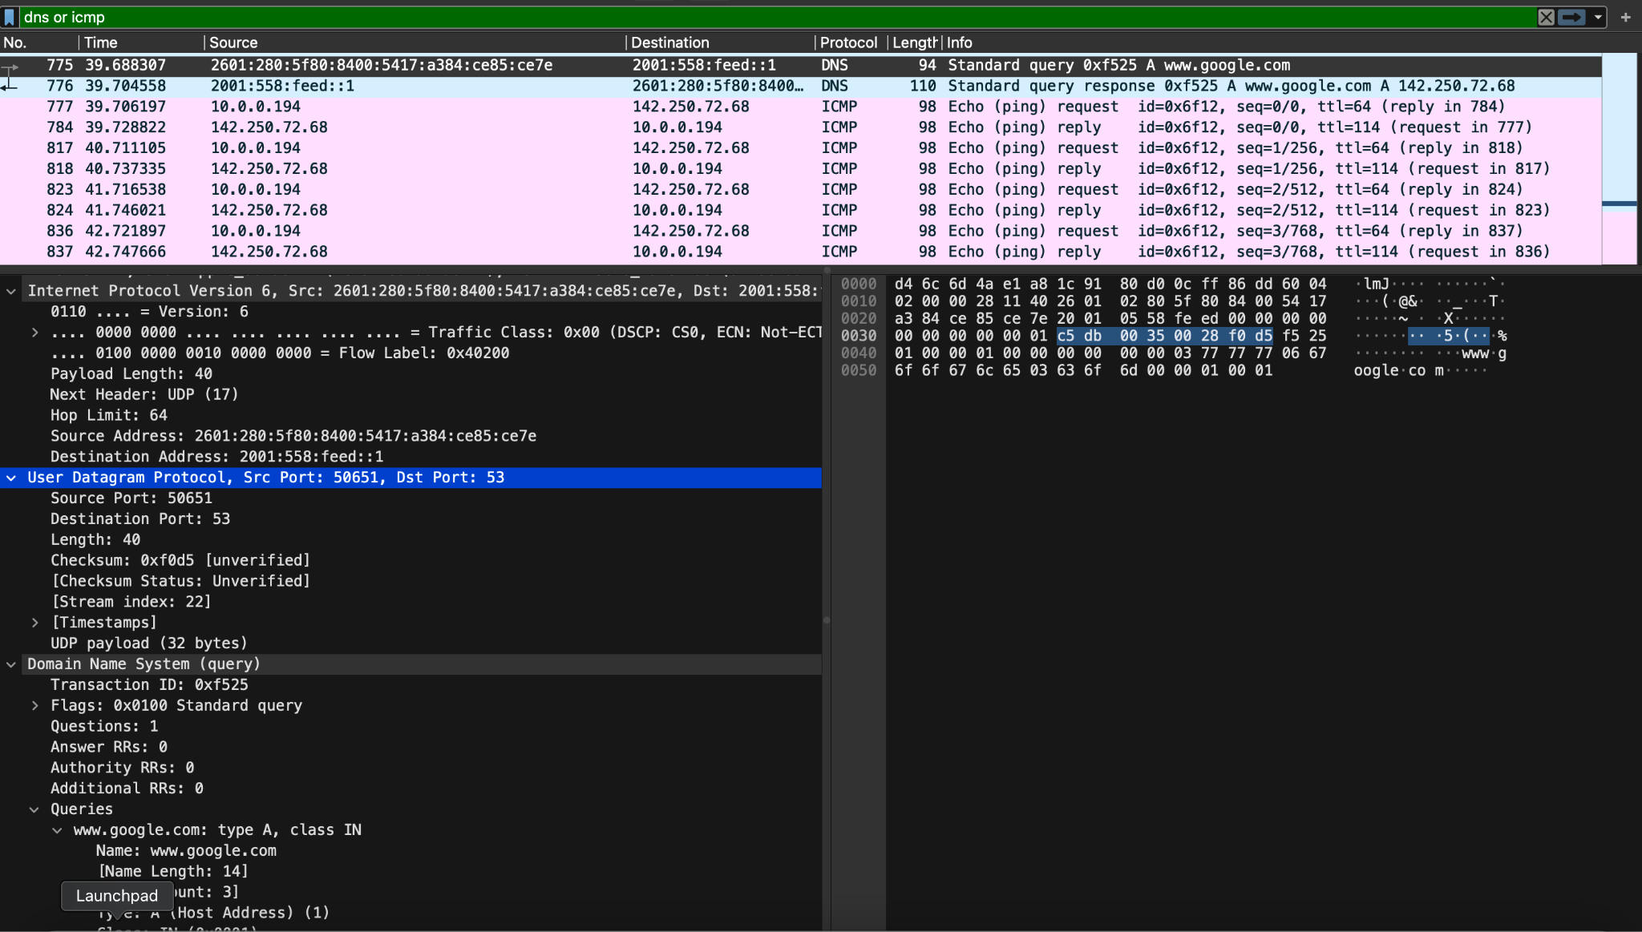

1. Next, the DNS server resolves google.com to 142.250.72.68 and responds to the client.
   1. On examining the headers, we can see that the source port is UDP 53 (which is what DNS operates on), the destination port is client’s port.
   2. In the “Answers” section, we can see that the DNS server responds back with the ipv4 address of [www.google.com](http://www.google.com) in “Address” parameter and sends it to my host.

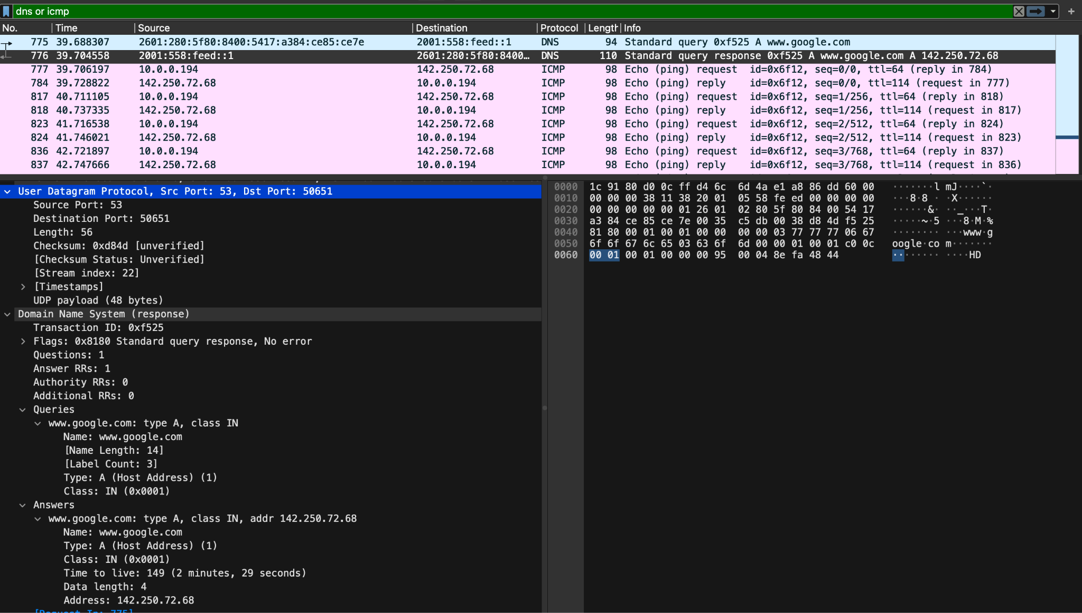

1. Once my host received the ipv4 address, the ping is resumed and successful!
2. Examine one of the ping request packets sent by your host. What are the ICMP type and code numbers? What other fields does this ICMP packet have? How many bytes are the checksum, sequence number, and identifier fields? [**10 points**]

I see that all the ping requests have ICMP type 8 which is an “echo request”. All the ICMP codes are 0. ICMP packet has checksum, checksum status, Identifier, sequence numbers, timestamp and data. The checksum is 2 bytes, sequence number is 2 bytes, identifier fields are 2 bytes as well.

1. Examine the corresponding ping reply packet. What are the ICMP type and code numbers? What other fields does this ICMP packet have? How many bytes are the checksum, sequence number and identifier fields? [**10 points**]

I observe that the ICMP type for echo ping response is 0 and code is 0 as well. As above, the ICMP packet has checksum, checksum status, Identifier, sequence numbers, timestamp and data. The checksum, sequence numbers and identifier fields are 2 bytes each.

1. Start a new Wireshark Capture. Ping a hostname or IP that gives you a “Request Timed Out” message. (e.g. You can try [www.wellsfargo.com or](http://www.wellsfargo.com/) any another website/IP of your choice.). Filter the ICMP traffic. Find the Type and Code of the packet in the above scenario. Paste the relevant screenshots. [**5 points**]

I only see ICMP type 8 and not 0 since the website was not reachable it could not send an ICMP response back. However, since all echo requests are ICMP type 8, I’m able to see 3 ICMP type 8s in my capture. All the ICMP codes are 0.

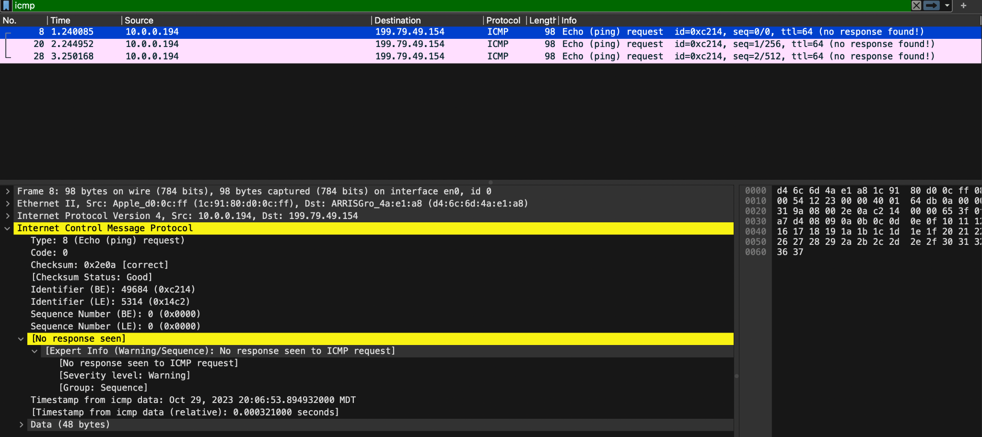

1. Do you see both ICMP Echo Request and Echo Reply messages? [**5 points**]

No. I only see ICMP echo request with no echo reply messages. In all ICM echo requests, the info field also mentioned “no response found!” which indicates that the website I was trying to reach, did not respond to my pings.

# Objective 2.2 – ICMP and Traceroute

1. Open command prompt/terminal (depending on the operating system)
2. Start Wireshark and begin capture
3. Traceroute to a “hostname” (where the “hostname” is a URL, example: tracert [www.google.com](http://www.google.com))
4. When trace completes, stop capture.
5. Provide a screenshot of the trace. Was it successful? How do you know? [**5 points**]

Yes, the trace was successful.

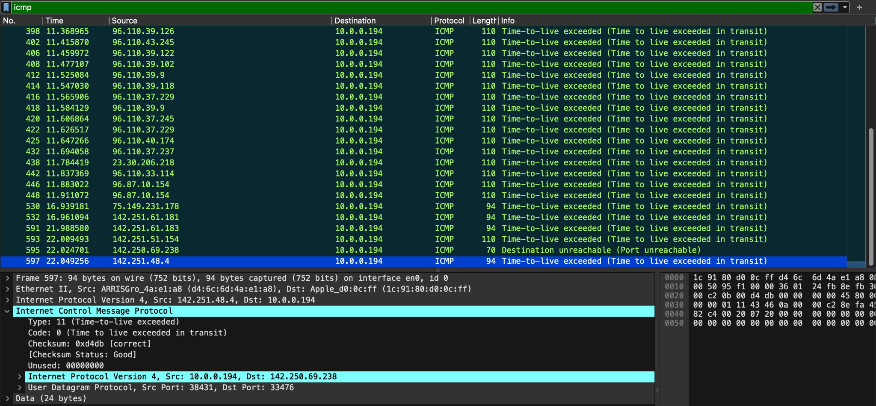

Destination 142.251.48.4 responded to the traceroute.

1. Filter the Wireshark capture to only show the relevant trace route data. Examine the ICMP traffic in Wireshark. What is different in the capture from the trace when compared to the capture of the Ping in previous objective? Explain what is different between the Ping and the traceroute, and how this relates to how traceroute works [**15 points**]

Ping is a simple network utility used to test the reachability of a host by sending ICMP Echo Request (*ping*) packets and waiting for ICMP Echo Reply packets in response. It's used to check if a host is online and measure the round-trip time (*latency*). Traceroute, on the other hand, is used to trace the path taken by packets to reach a destination. It works by sending ICMP packets with increasing TTL (*time to live*) values and observing the ICMP Time Exceeded responses from intermediate routers.

**ICMP Packet Type**: In the ping capture, there are ICMP Echo Request and Echo Reply packets. In the traceroute capture, you see ICMP Time Exceeded packets, which are generated by routers when the TTL of a packet expires.

**Purpose**: Ping is used for host reachability and latency testing. Trace route is used to map the network path to a destination and identify the routers or hops along the way.

**Packet Behavior**: In Ping, you send an echo request and receive echo reply. In traceroute, you send packets with increasing TTL values and receive ICMP Time Exceeded responses from routers along the path, which helps you trace the route.

**TTL**: The Time to Live (TTL) value is manipulated in traceroute to control how far the packet can travel in the network.

# Part 3 – Wireshark NICs and IPv4/IPv6 addresses

Objective 3.1

1. Provide a screenshot of the NICs that Wireshark has to choose from on the PC. **[10 points]**

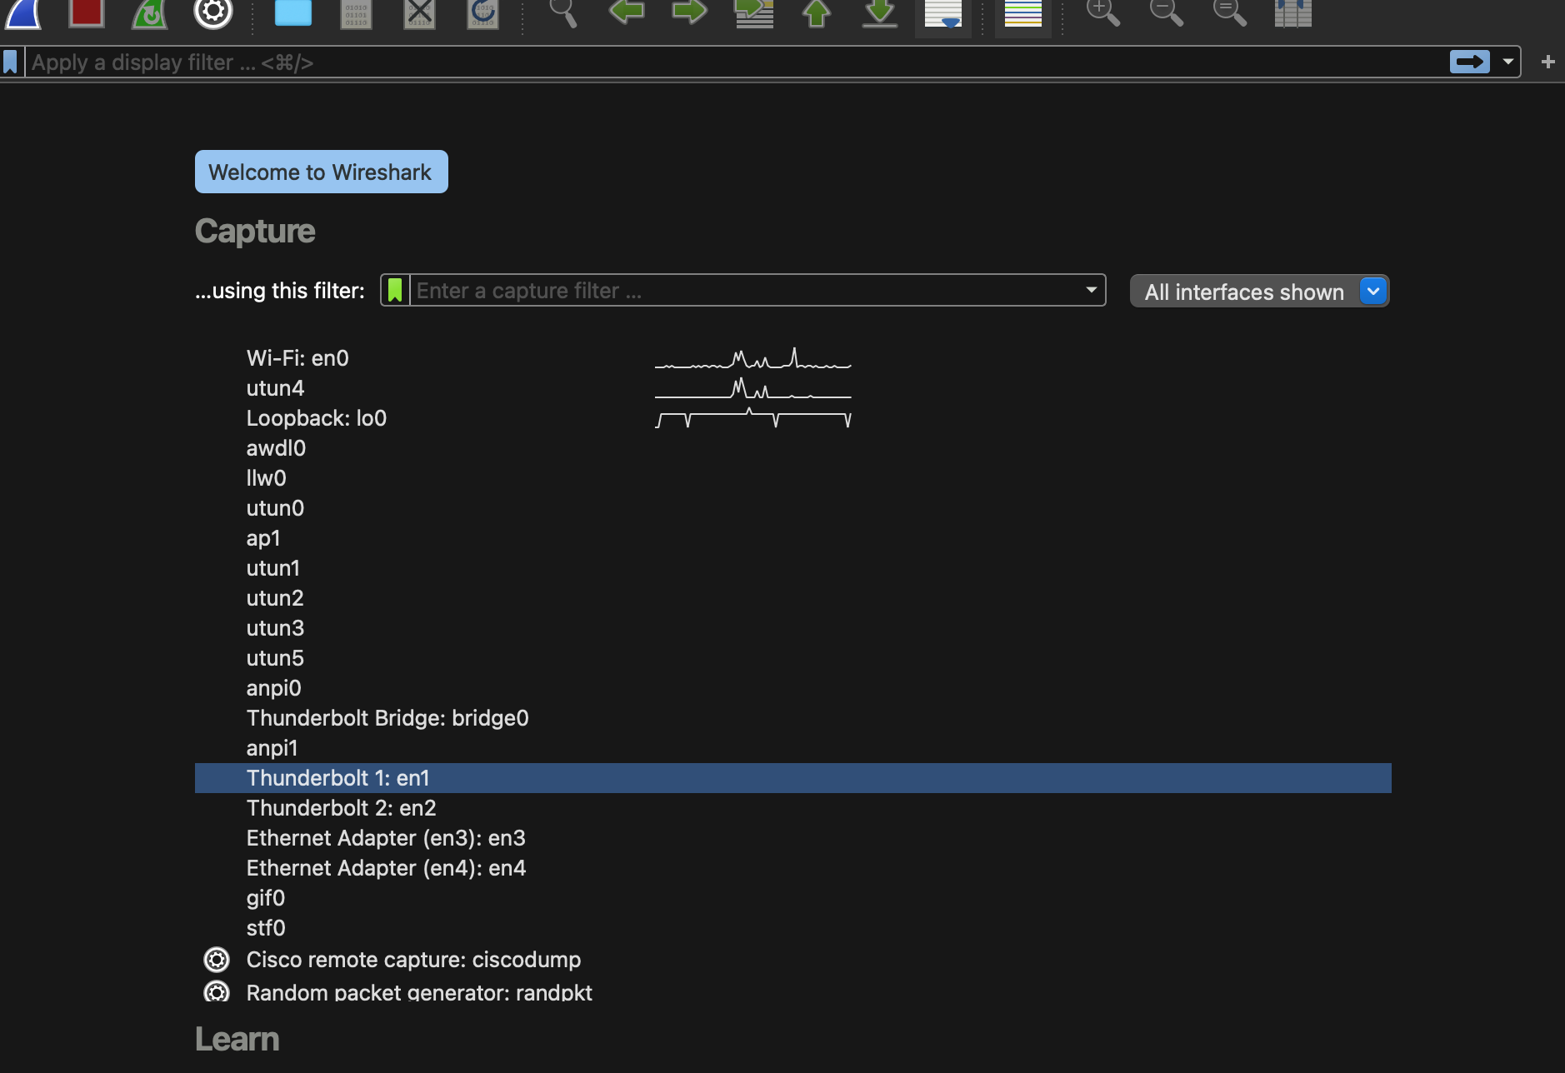

1. Which interface is currently capturing traffic? How do you know? (Provide a screenshot) **[10 points]**

The wireshark application’s title bar has the name of the interface it captures. It says “Capturing from Wi-Fi: en0”.

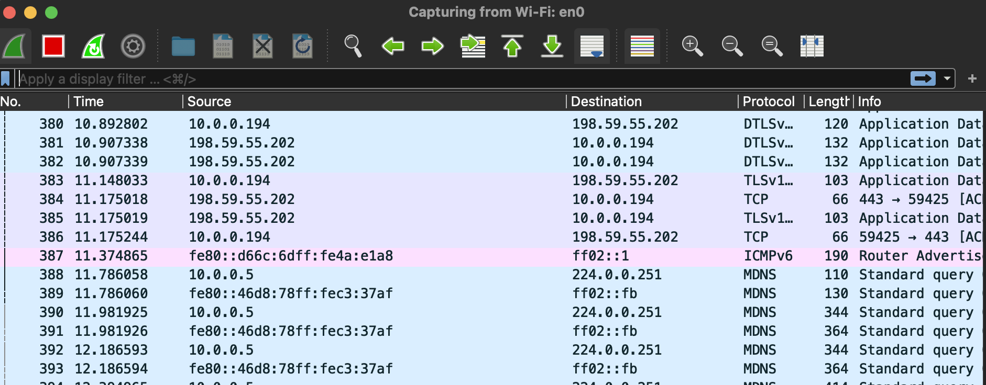

1. What is the easiest way to determine the IPv4/IPv6 address of the NICs before a capture is started? Provide a screenshot where some NICs show IPv6 addresses and some show IPv4 addresses. **[10 points]**

You can check the ipv4 and ipv6 addresses via Capture > Options and expanding on each of the NICs.

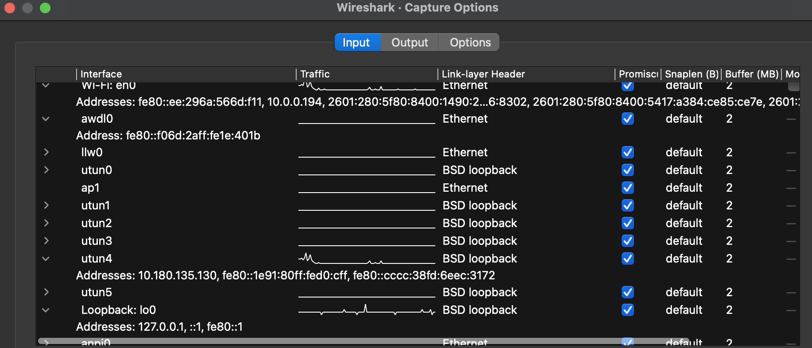

# Part 4 – Continuous Captures, Filtering, and Analysis

# Objective 4.1

1. Initiate a Wireshark capture that uses multiple files, where it creates a new file every 5 minutes, for a total of 15 minutes. (Provide a screenshot of the Capture Options you selected). Remember where you save this file, as we will use it in the future. Also, try to use the wireless NIC if possible, as there will be more traffic in the capture to analyze. **[15 points]**

Here are the capture options I selected to generate a new file every 5 minutes for total of 15 minutes.

1. Browse ten different websites, during this 15-minute continual capture time window.
2. What are THREE reasons why you would want to create multiple files? **[15 points]**

1. Large network captures can quickly become unwieldy. By segmenting data into multiple files, you can effectively manage and analyze specific segments of network traffic.

2. Separate files enable you to apply filters to isolate and analyze particular network events, protocols, or specific time periods, making it easier to troubleshoot and detect issues.

3. When collaborating with team members or sharing data, smaller, segmented files are more manageable and easier to distribute and analyze, especially when different experts are responsible for different aspects of the analysis.

1. How do you view the three files captured within Wireshark, and move between them, after they have been completed and saved? (Hint: File > File Set) **[10 points]**

Open Wireshark and make sure you've saved the three capture files that you want to view.

Go to the "File" menu at the top of the Wireshark window.

Select "File Set."

Select “List Files”

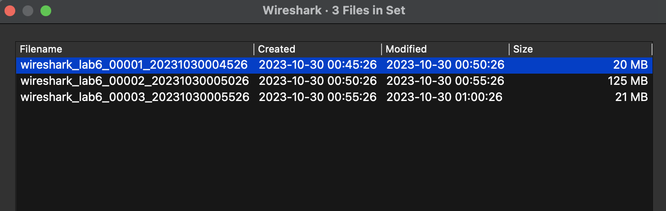

1. How do you see which websites you browsed during the capture? (Hint: Statistics > HTTP) **[5 points]**

Since, I browsed for HTTP traffic, click on Statistics > HTTP. It gives a consolidated list of all the sites you browsed.

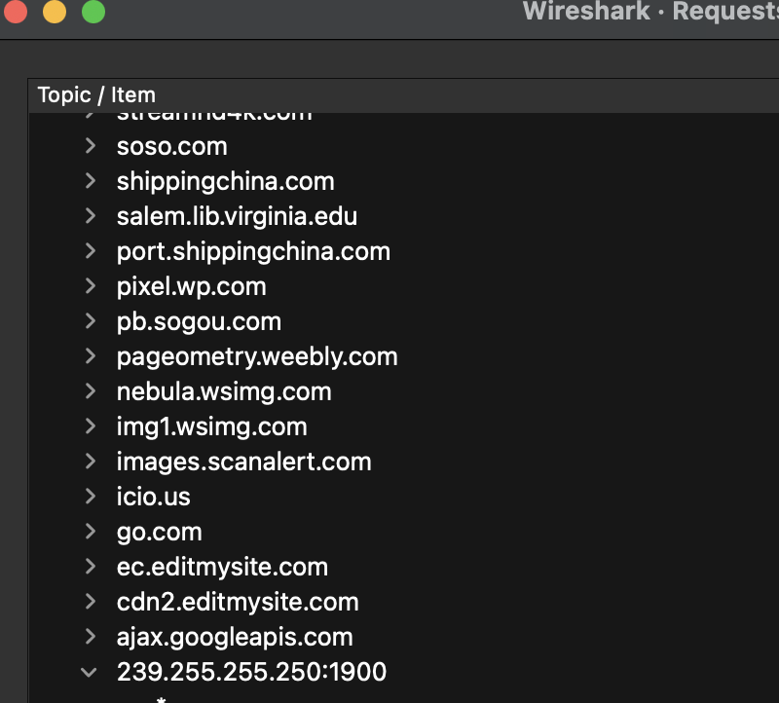

# Objective 4.2

1. Create two Display filter buttons. One for traffic sourced from your machine’s IP address and one that only displays HTTP GET requests. (Hint: HTTP contains)
2. Provide a screenshot of the buttons you created, and the corresponding filtered capture. **[10 points]**

# Button for HTTP GET request:

# 

# Button where my machine is the source IP address:

# 

# Objective 4.3

1. Create a coloring rule for HTTP traffic. **[5 points]**

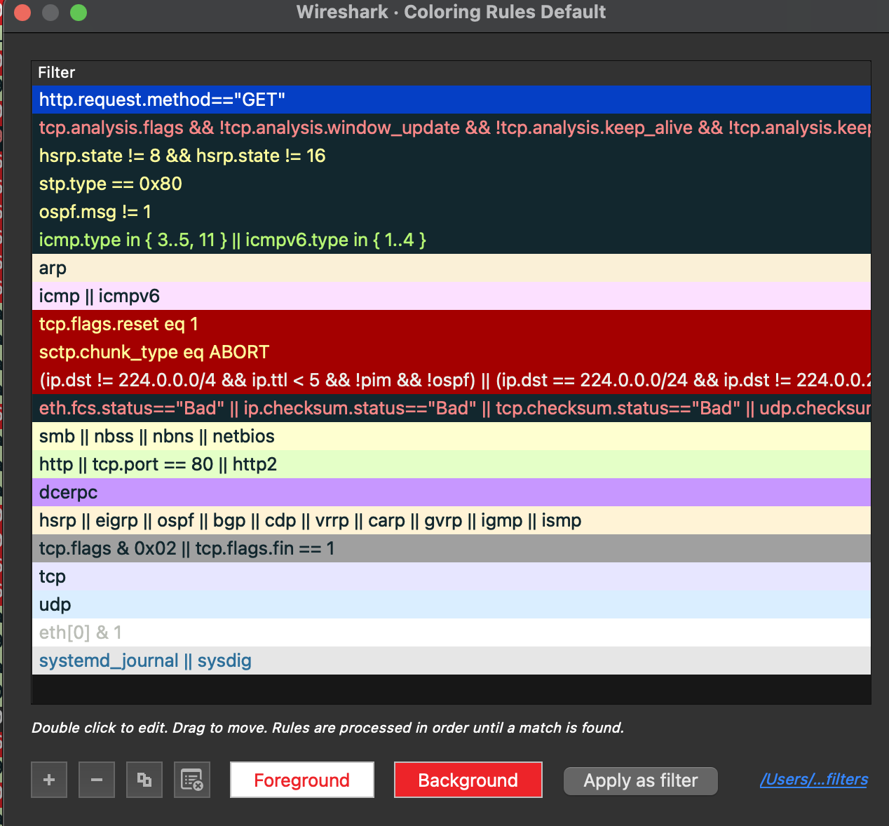

1. Provide a screenshot of your capture from above, showing where you changed the color of HTTP GET requests to Red background with White lettering. (Hint: Did you remember to move your color rule to the top?) **[10 points]**

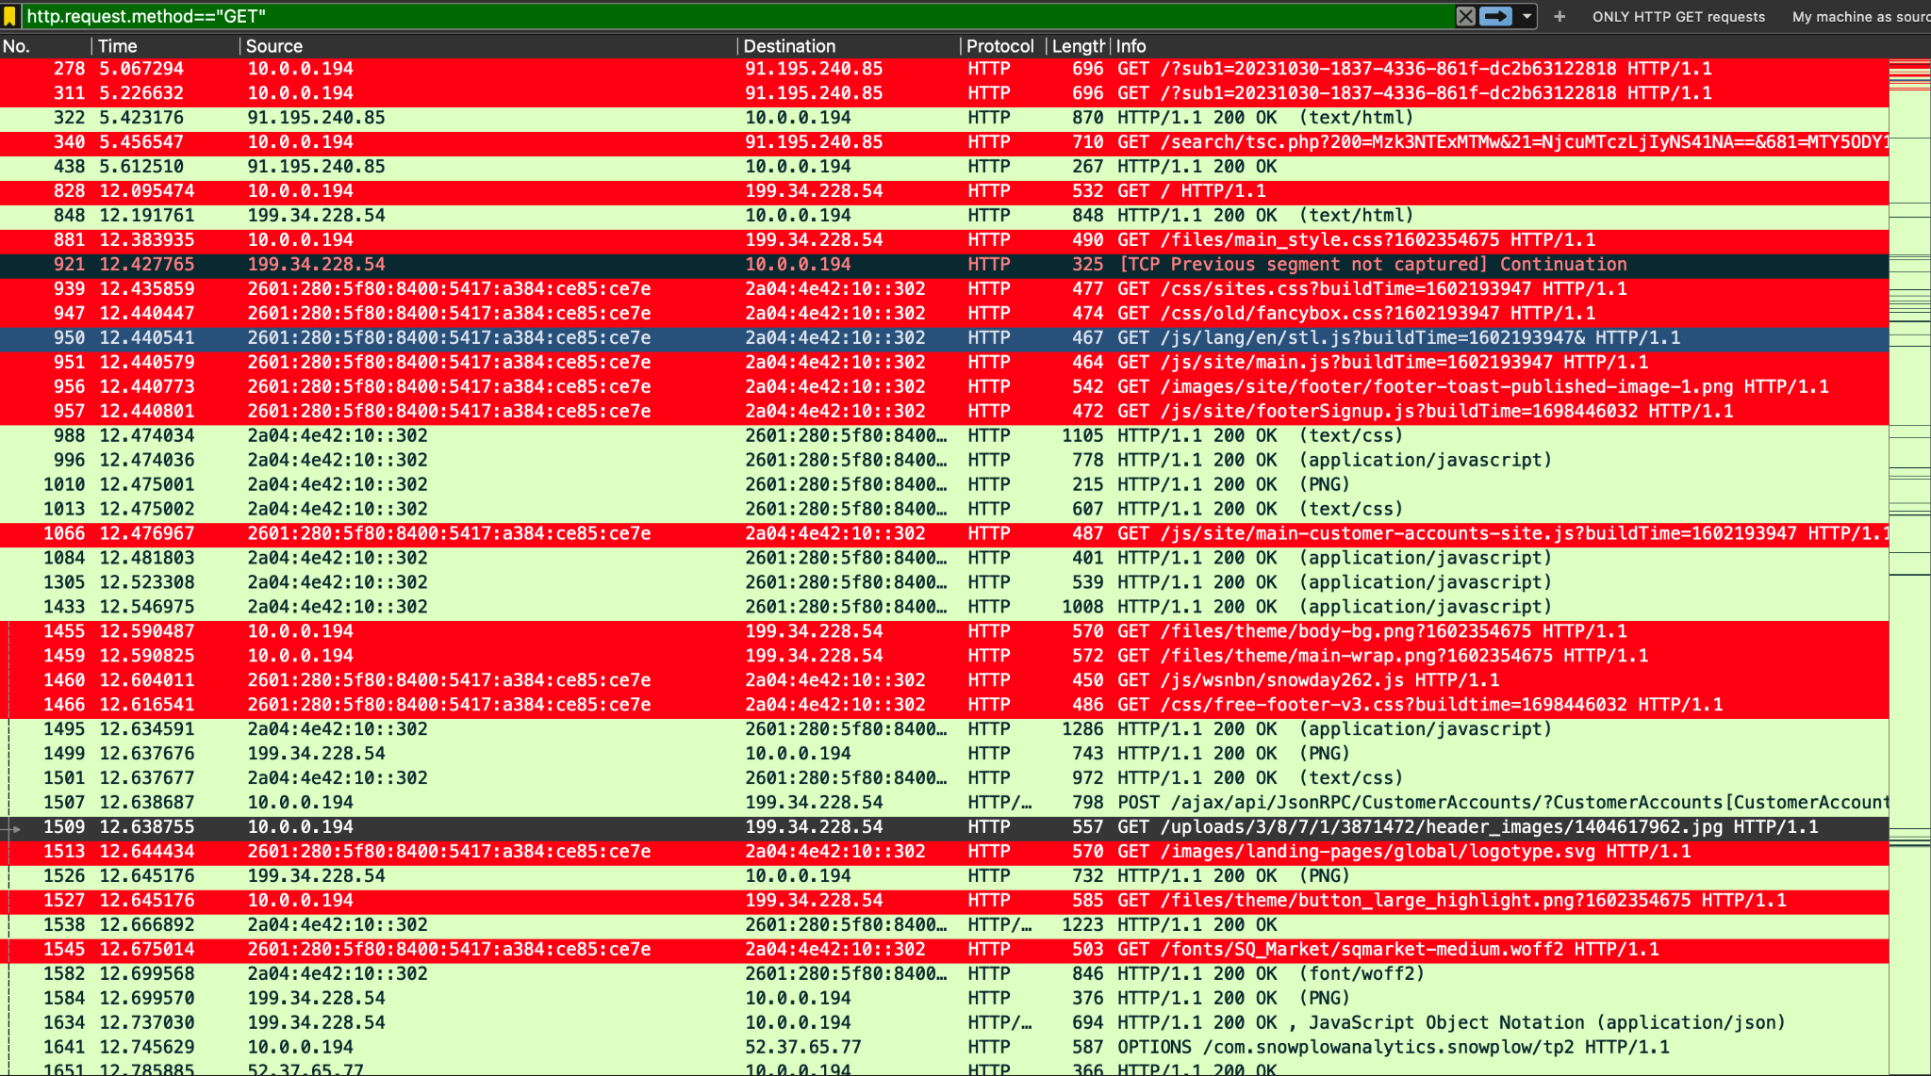

# Part 5 - Top Talkers, Profiles, and Graphs

# Objective 5.1

1. Determine Top Talkers on the network. **[10 points]**

The top 5 talkers on the network are (198.59.55.202,224.0.0.251,40.99.253.114,40.99.169.256,52.112.39.35)

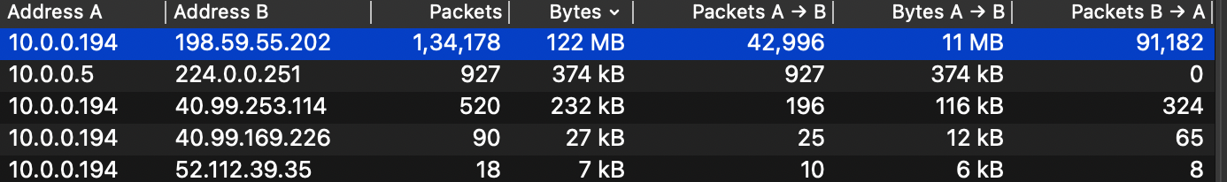

I was able to determine this using Statistics -> Conversations. I sorted the “Bytes” (no. of bytes transmitted/received) field in descending order to determine the top talkers.

1. What are two ways you can determine what device/IP address is transmitting the most traffic on the network? Provide a screenshot of one of those ways. (Hint: Protocol Hierarchy; Conversations; Endpoints) **[10 points]**

The easiest and fastest way is to use the Endpoint Statistic via “Statistics” -> “Endpoints”. You can choose between ipv4, ethernet, ipv6, udp, tcp, etc.

The other way, as shown above, is via “Statistics” >> “Conversations”

# 

# Objective 5.2

1. Create a graph that displays the top 4 protocols from the capture.
2. Provide screenshot of the graph. **[10 points]**

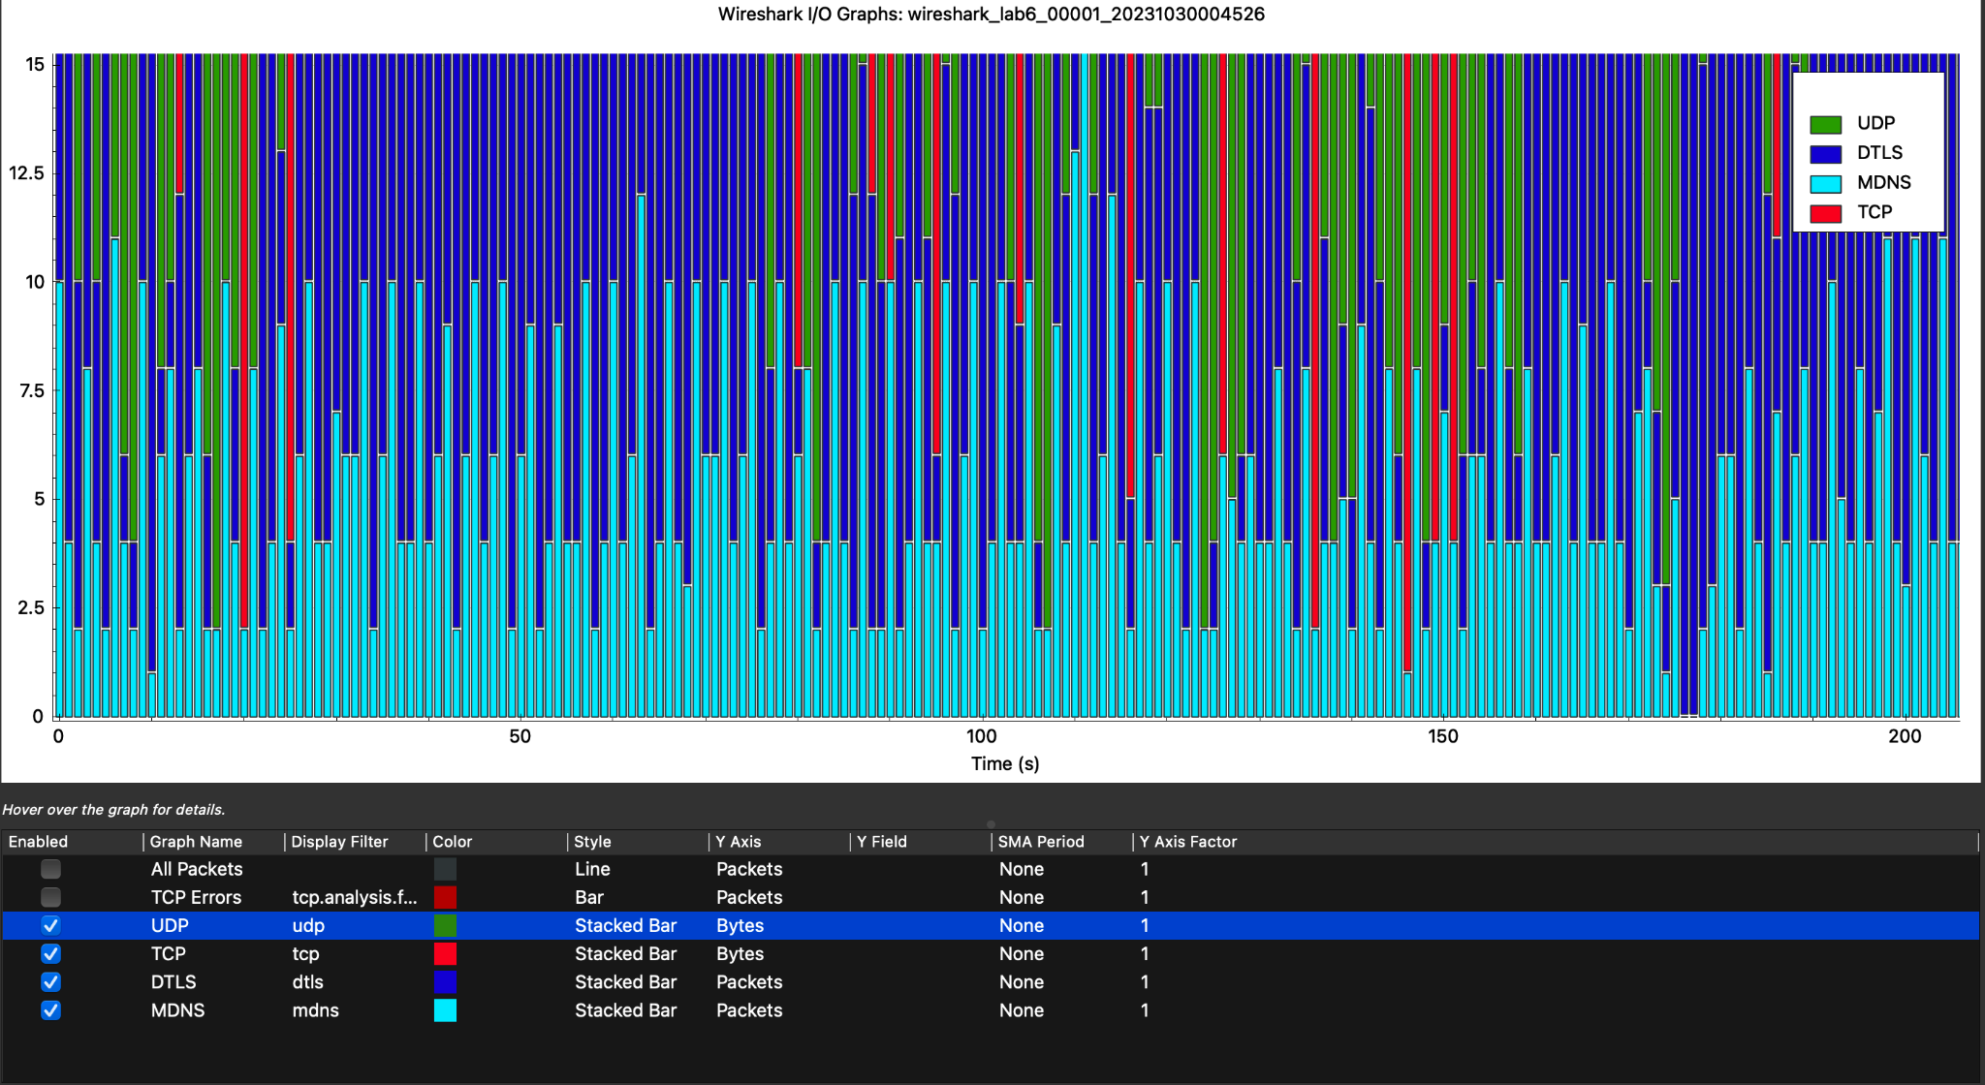

# Objective 5.3

1. Create three profiles that you will use for future analysis objectives. For example, Security, Troubleshooting, VoIP, etc. **[10 points]**

I created 3 profiles: Web Traffic Profile, Troubleshooting Profile, and DHCP Profile.

1. Explain what you would use each profile for, what you changed, and provide a screenshot of one of them. **[10 points]**

**1. Web Traffic Profile:**

This profile is valuable for various use cases related to monitoring and troubleshooting web-related network traffic. It can also be used to diagnose problems with web applications by examining HTTP error codes, response headers, or unexpected behavior in web traffic.

**Configuration:**

**Display Filters:**

For HTTP:

Filter Expression: http

Description: "HTTP Traffic"

—

For HTTPS (encrypted traffic):

Filter Expression: tls and tcp.port == 443

Description: "HTTPS Traffic"

**Coloring Rules:**

http.response.code > = 400: Red background with white text.

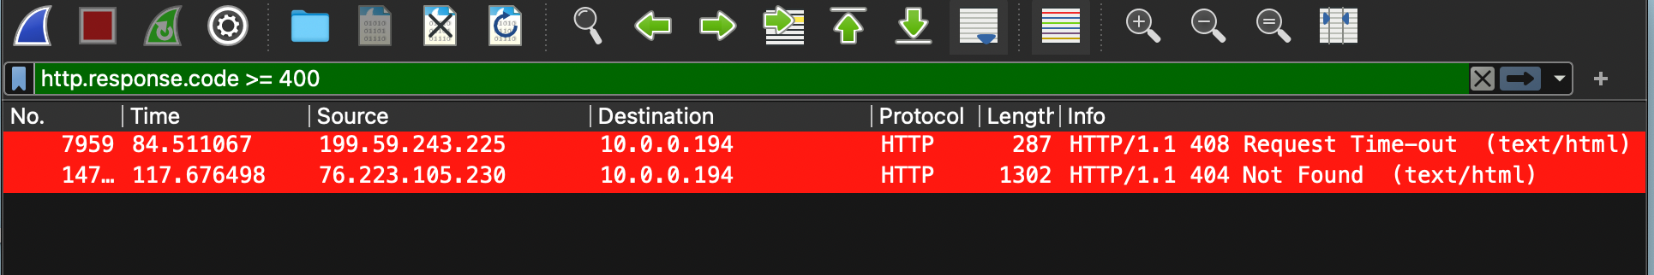

**2. Troubleshooting Profile:**

This profile can be used for troubleshooting any issues with ARP or DNS traffic (which can later be expanded to more filters)

**Configuration**:

For ARP:

Filter Expression: arp

Description: "ARP Traffic"

–

For DNS:

Filter Expression: dns

Description: "DNS Traffic"

**Coloring Rules:**

arp.opcode == 1 to highlight ARP requests and ARP replies (arp.opcode == 2) : Green

dns.flags.rcode != 0 to highlight DNS packets with non-zero response codes: Red background with white text

**3. DHCP Profile:**

The DHCP profile can be used to identify connectivity and configuration issues, such as IP address allocation problems or DHCP server availability. It can also be used to analyze DHCP traffic to detect unauthorized DHCP servers and protect against potential security risks, monitor IP address allocation, lease durations, and conflicts for efficient IP address management.

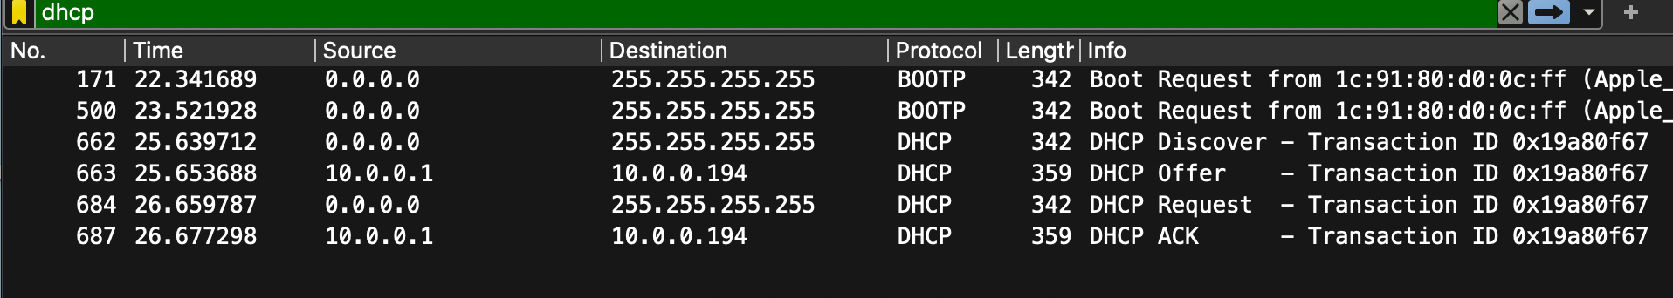

**Configuration:**

Filter DHCP packets by using dhcp as filter expression.

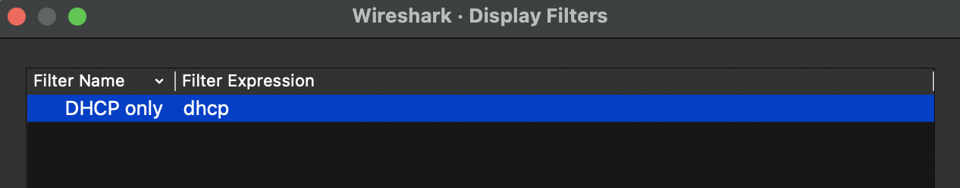

Added coloring rules in case for any DHCP NAK or IP releases.

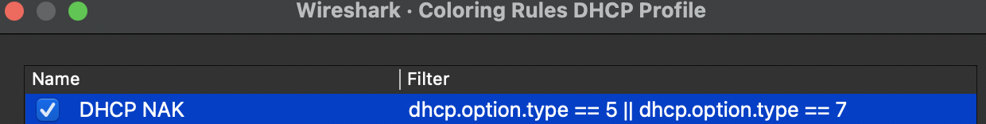

# Part 6 - DHCP Release and Renew

# Objective 6.1

1. Start Wireshark and begin capture
2. Release the DHCP IP address your machine has obtained
3. Renew the DHCP IP address (for your machine to obtain a new address)
4. After your machine receives an IP address from the DHCP server, stop the capture
5. Filter the capture to only show the DHCP traffic. From the capture indicate the following:
   * 1. DHCP server address [**2 points**]

10.0.0.1. We know this because 10.0.0.1 acknowledged and responded to the DHCP request.

* + 1. The IP address your machine was offered and accepted [**2 points**]

10.0.0.194

* + 1. Explain the DHCP process, include a screenshot [**10 points**]

**DHCP Discovery**: When a device, connects to a network, it typically doesn't have an IP address. So, it sends out a DHCP discovery request as a broadcast message to find a DHCP server. This request is in the form of a DHCPDISCOVER packet. Since the device does not have an IP, the source is 0.0.0.0 and the destination is 255.255.255.255.

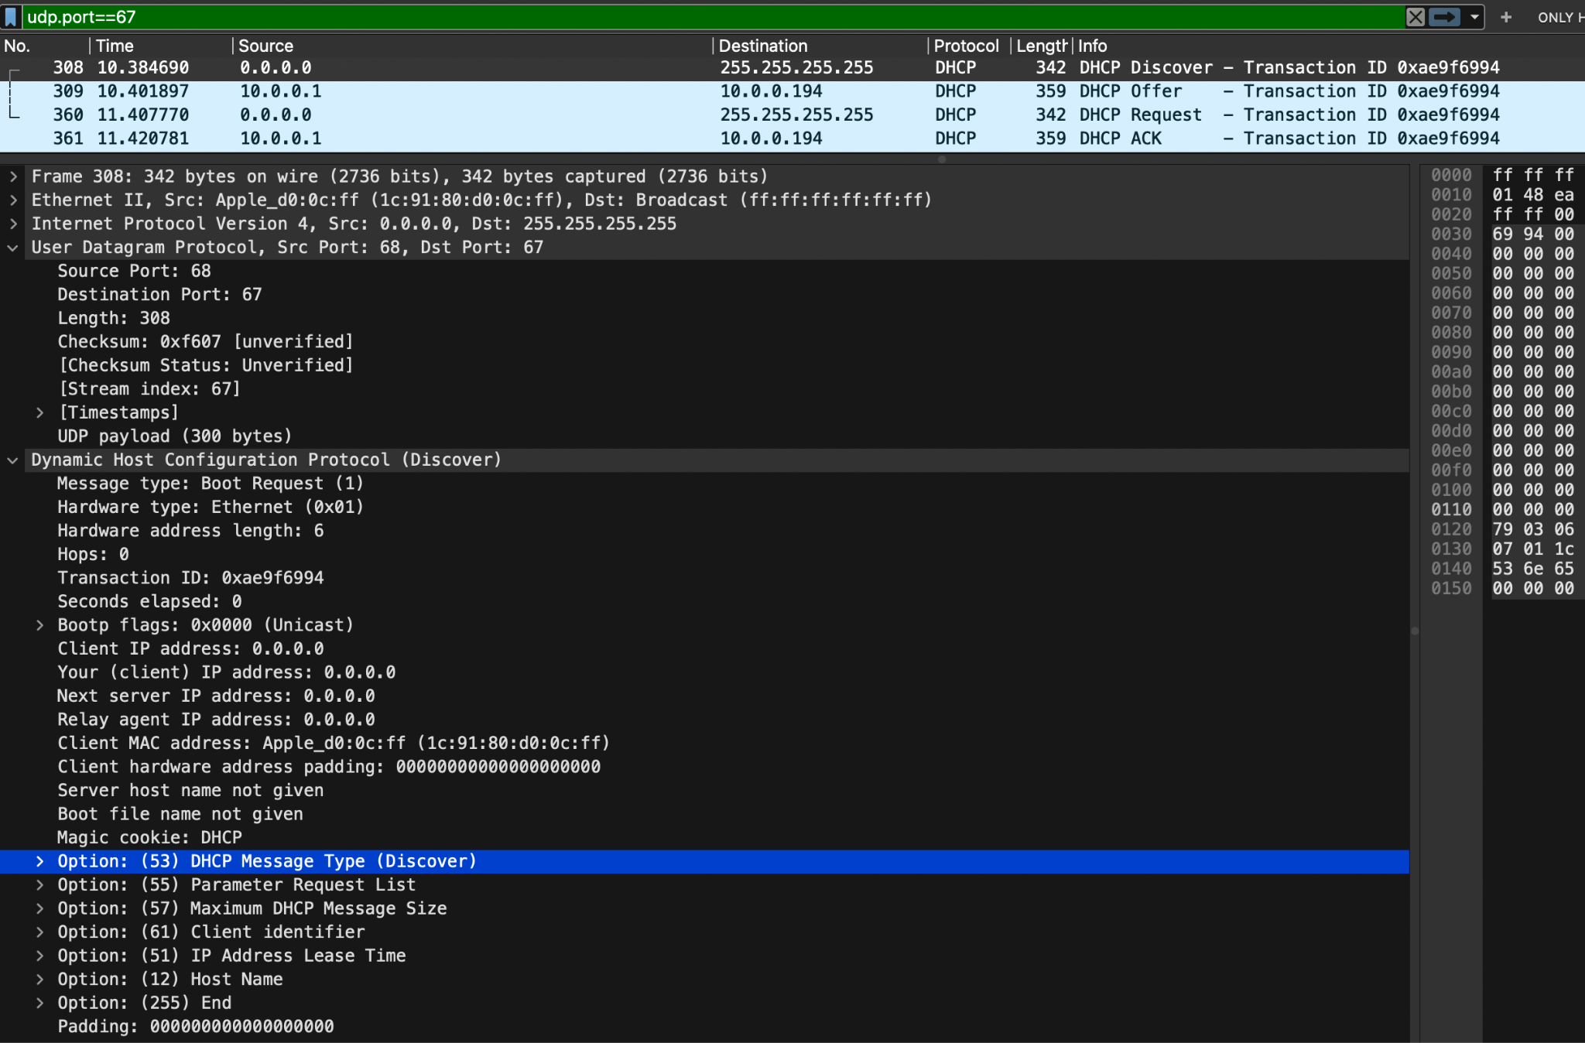

**DHCP Offer**: A DHCP server on the network receives the DHCP discovery request. If the server has available IP addresses to lease, it responds with a DHCP offer. This offer includes an available IP address and various network configuration settings. The offer is sent as a DHCPOFFER packet. In my case, the offered IP address is 10.0.0.194.

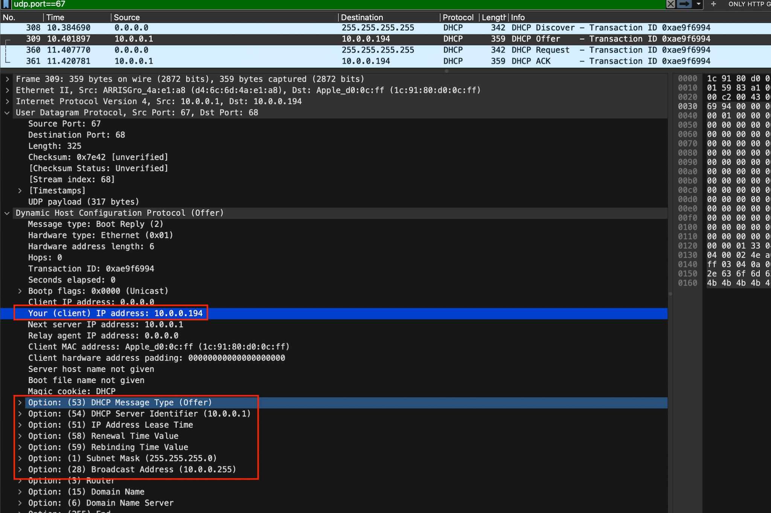

**DHCP Request**: The client then chooses the offer and sends a DHCP request to the DHCP server. This request acknowledges the offered IP address and confirms the network settings. The request is sent as a DHCPREQUEST packet.

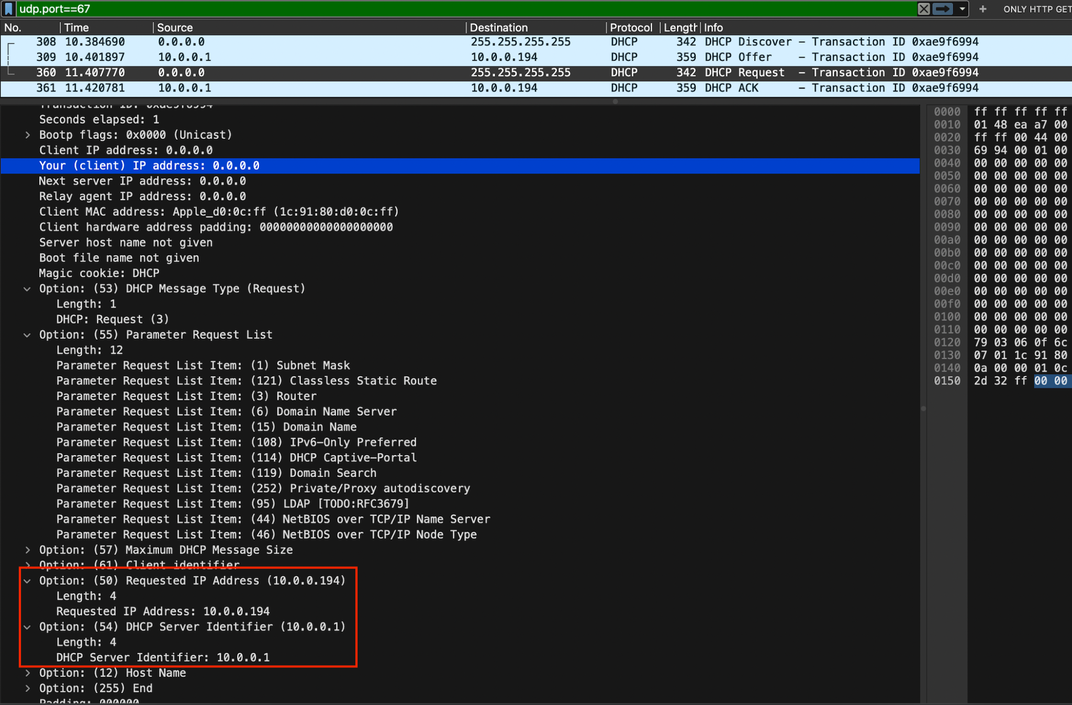

**DHCP Acknowledgment**: The DHCP server that received the DHCP request then responds with a DHCP acknowledgment (DHCPACK) to the client. This acknowledgment confirms the IP address lease and provides all the network configuration settings and updates its pool

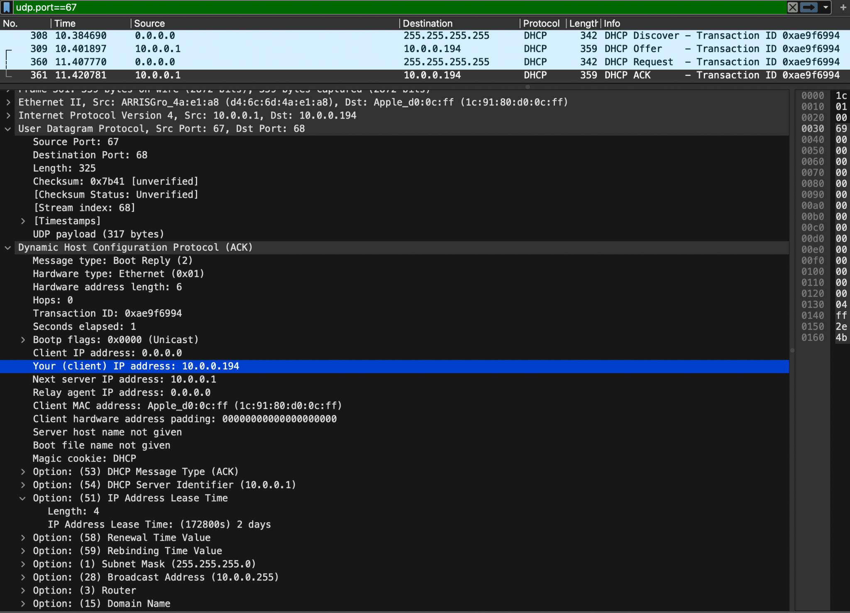

Part 7 – Web traffic (HTTP) and TCP Connection

# Objective 7.1

1. Start Wireshark and select the appropriate interface to begin capturing packets.

2. Go to <http://gaia.cs.umass.edu/wireshark-labs/INTRO-wireshark-file1.html> in your browser and capture the web session on Wireshark.

3. How is the TCP connection established? Explain the process. What is it called? Locate it in your Wireshark capture. Paste relevant screenshots. **[5 points]**

The TCP connection is established by the process called a 3-way handshake.

**Step 1: SYN (Synchronize) - Client to Server:**

The client sends a TCP segment to the server with the SYN (synchronize) flag set. This segment includes an initial sequence number (ISN) chosen by the client to start the sequence of data. This segment is the “SYN” packet.

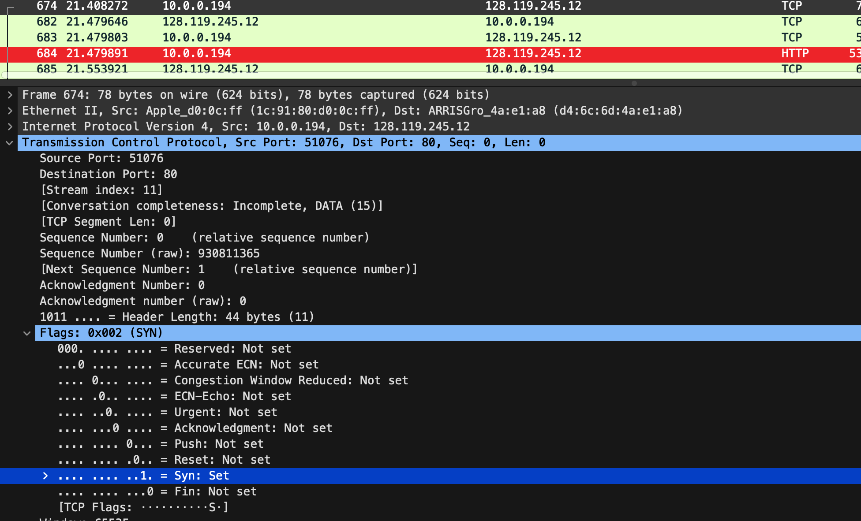

**Step 2: SYN-ACK (Synchronize-Acknowledge) - Server to Client:**

When the server receives the SYN packet, it acknowledges the receipt of the request by sending a response back to the client. The server responds with a TCP segment that has both the SYN and ACK flags set. It also includes its own initial sequence number (ISN). This segment is a “SYN-ACK” packet.

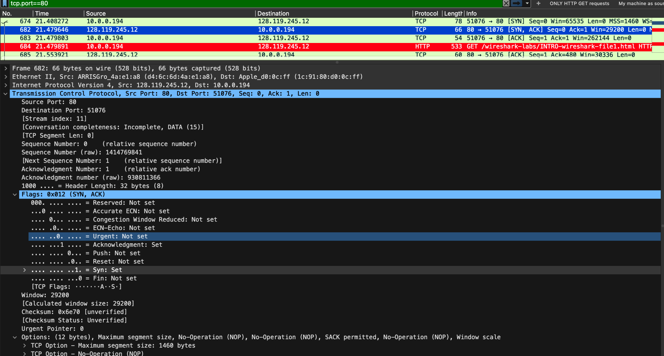

**Step 3: ACK (Acknowledge) - Client to Server:**

Upon receiving the SYN-ACK packet, the client sends a final acknowledgment to the server. The client's acknowledgment segment has only the ACK flag set. This segment is the "ACK” packet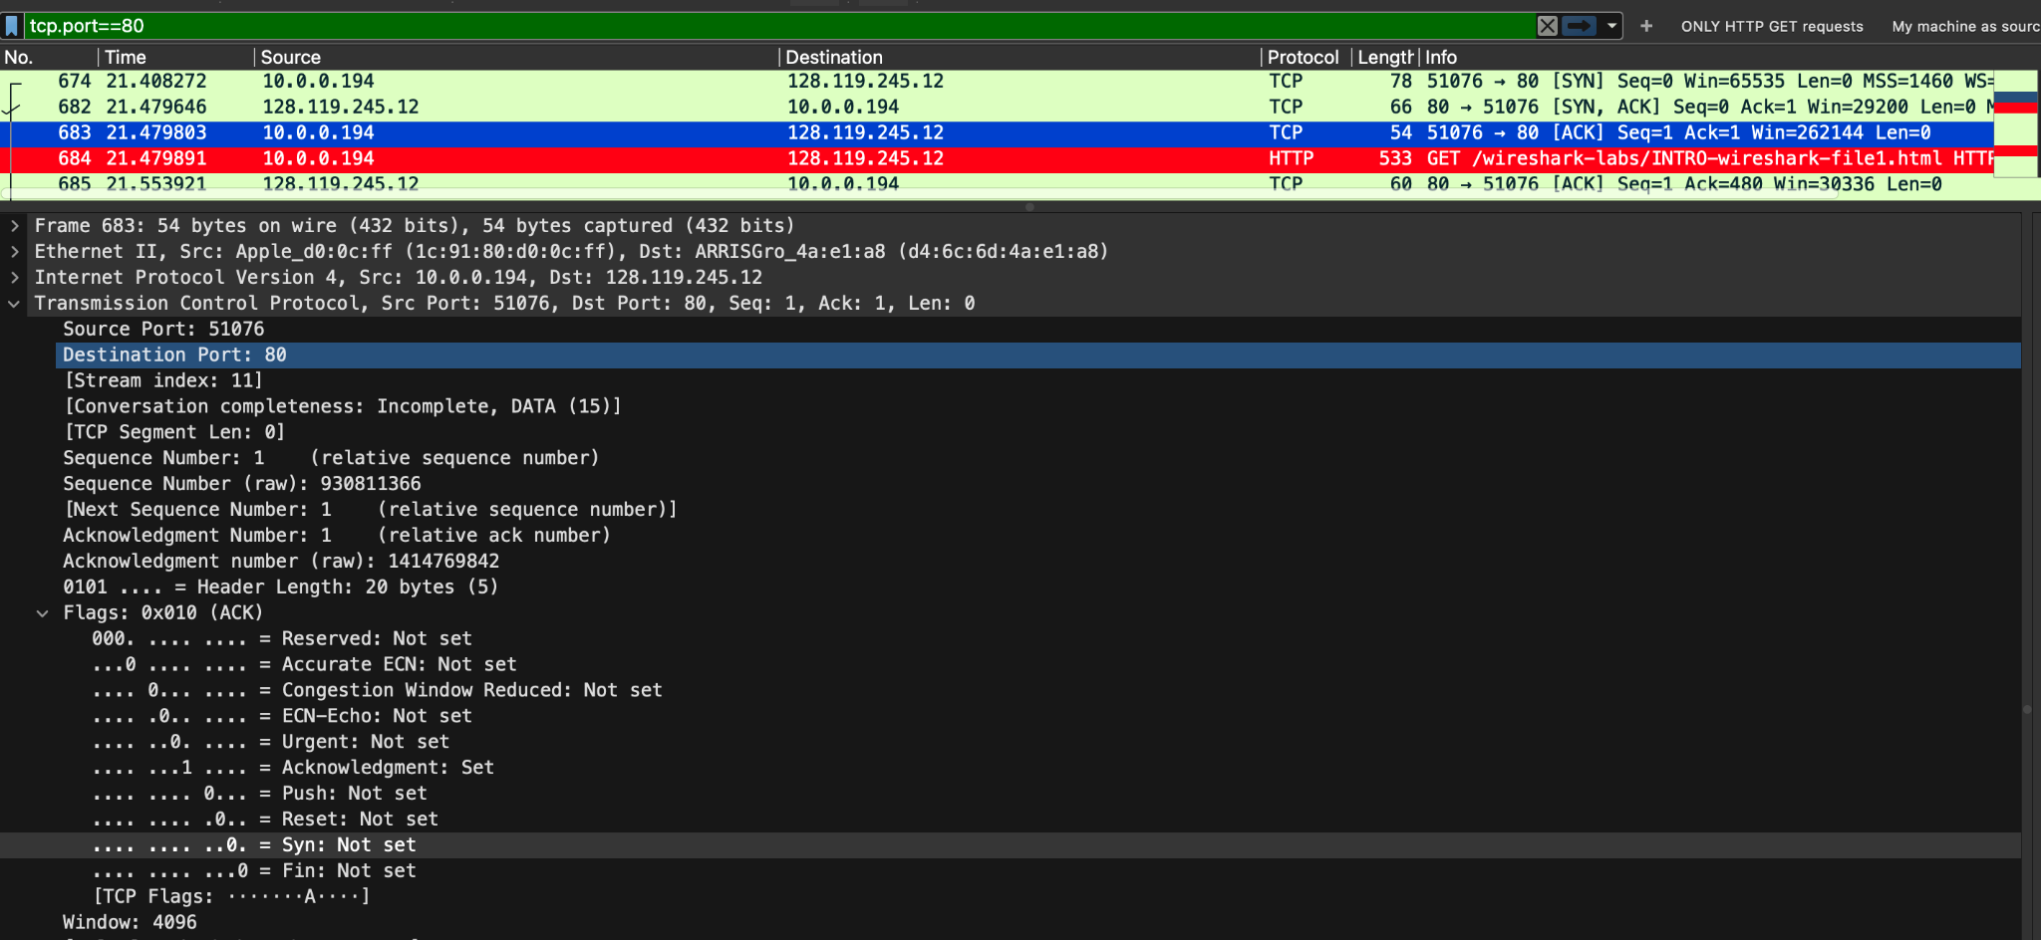

4. Inspect information within the first packet of the TCP connection process.

i. What is the destination port number? How would you classify it? **[1 point]**

The destination port number is 80. This is used for HTTP.

ii. Which control flag (or flags) is set? What does it imply? **[1 point]**

SYN flag is set. It implies that the client is trying to initiate a TCP connection with the server.

iii. What is the relative sequence number set to? **[1 point]**

It is set to 0.

5. Inspect the next packet in the TCP connection process.

i. Which control flag (or flags) is set? What do they imply? **[1 point]**

SYN and ACK flags are set. This implies that the server has acknowledged the SYN flag the client sent and sends a SYN packet to the client (since it works on full duplex)

ii. What is the relative sequence number and relative acknowledgement number set to? **[1 point]**

Relative seq number is 0 and relative ack number is 1.

6. Finally, inspect the third packet of the connection process.

1. Which control flag (or flags) is set? What do they imply? **[1 point]**

ACK flag is set. This implies that the client has acknowledged the SYN packet sent from the server.

1. What is the relative sequence number and relative acknowledgement number set to? What do they imply? **[1 point]**

Both relative sequence number and ack number is set to 1. The client responds to the server's sequence number of zero with an acknowledgement number of 1. The client includes its own sequence number of 1 (incremented from zero because of the SYN).

7. In your Wireshark Capture display only the HTTP (Web) traffic. (Paste screenshot). [**5 points**]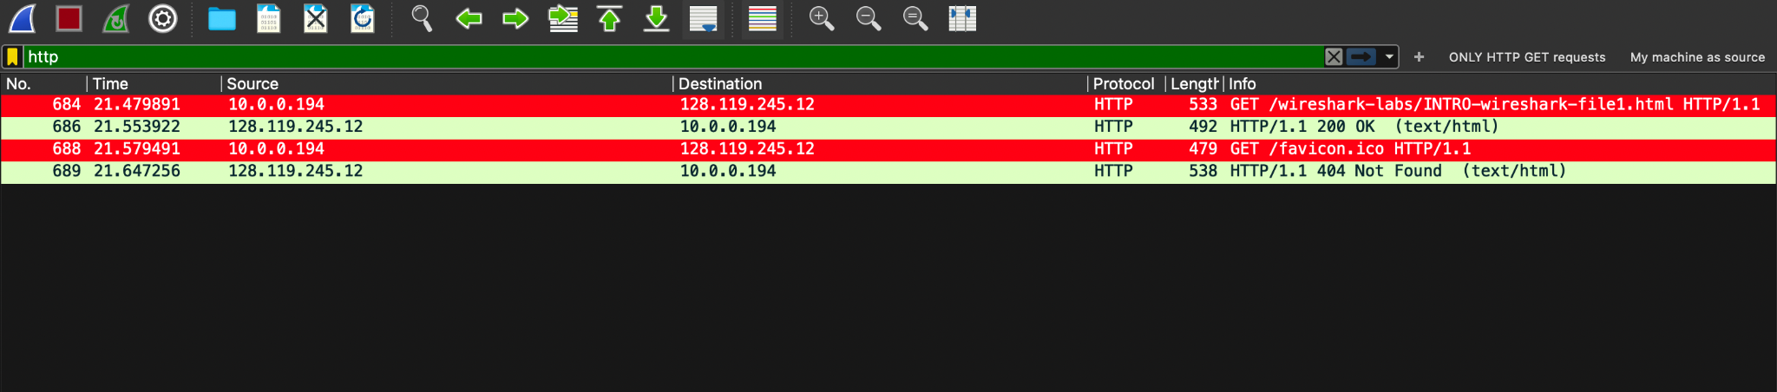

8. Examine the HTTP request packet. What is the destination IP address and destination port number? Which TCP control flag (or flags) is set, and what do they mean? Paste relevant screenshots. **[5 points]**

Destination IP: 128.119.245.12

Destination Port: 80

Flags set: PSH and ACK.

The PSH flag in TCP is used to instruct the receiving end to deliver the data to the application as soon as possible, rather than waiting for a full buffer of data to accumulate.

The ACK flag is used to acknowledge the receipt of data. It contains the sequence number of the next expected byte.

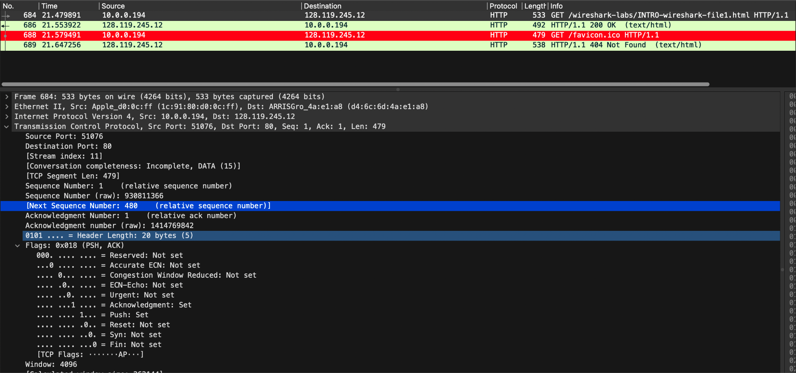

9. Examine the HTTP packets and answer the following questions -

i. What HTTP version is running on the client? What version of HTTP is the server running? **[2 points]**

Both client and server are running HTTP v 1.1

ii. What is the status code returned from the server to your browser? **[1 point]**

Status Code: 200

iii. When was the HTML file that you are retrieving last modified at the server? **[1 point]**

Last-Modified: Mon, 30 Oct 2023 05:59:02 GMT

iv. How many bytes of content are being returned to your browser? **[1 point]**

81 bytes

10. Can you see the text displayed on the browser in your Wireshark packets as well? Why/why not? Paste relevant screenshots. [**5 points**]

Yes, I was able to see the text displayed on browser in my wireshark packets. This is because the website is running HTTP, which is not secured and the traffic is not encrypted as well. All the text is clearly displayed when any web server uses HTTP. 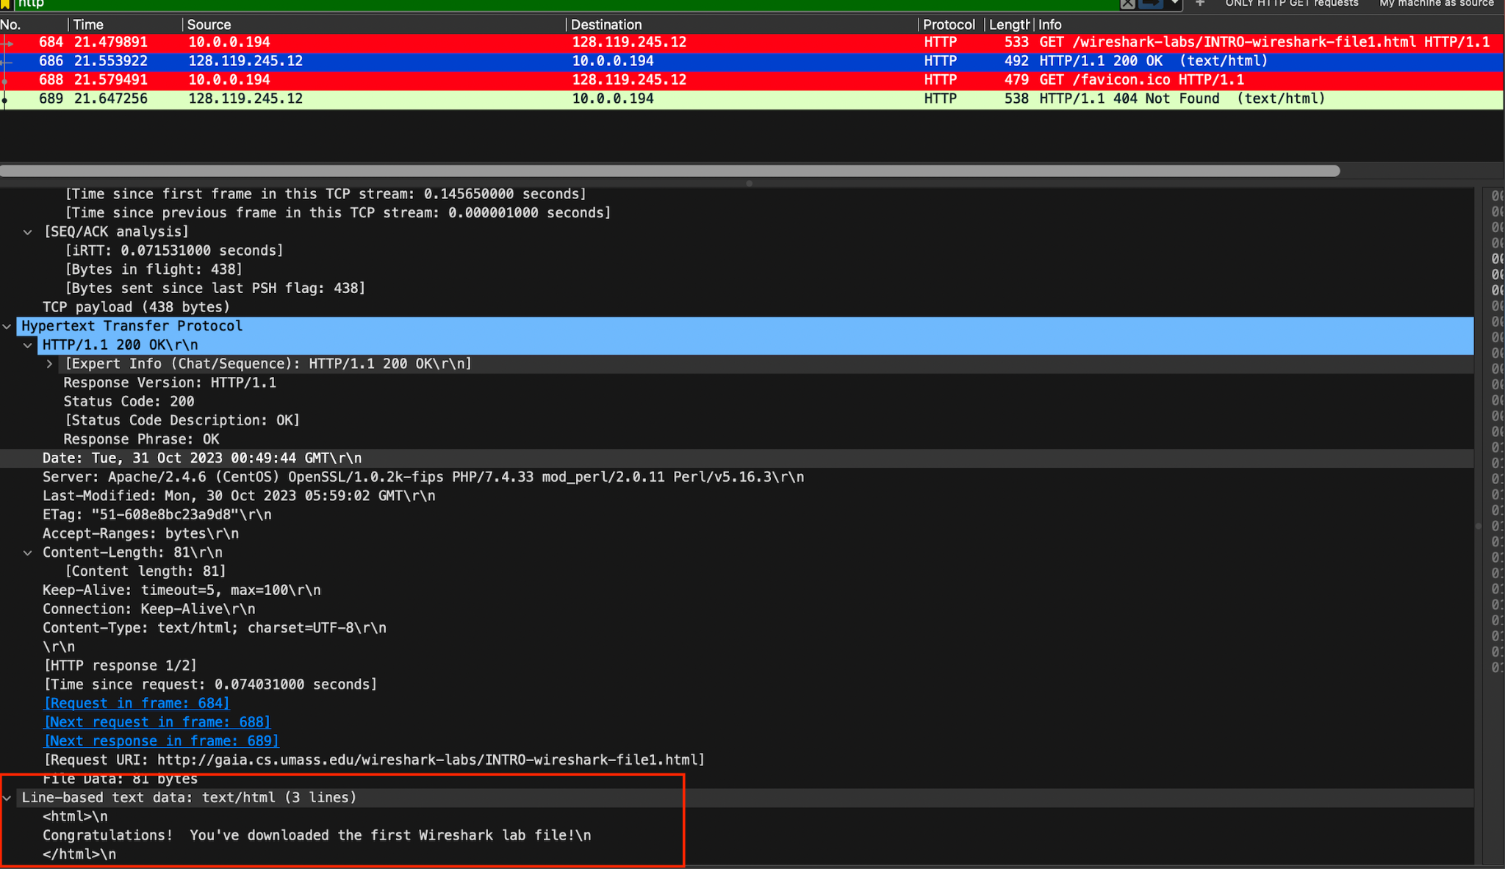

Part 8 – Parsing .pcap using Python [Extra Credit]

# Objective 8.1

1. Start a new capture in Wireshark using the capture filter of ‘icmp’. Open the command prompt/terminal and execute these commands -

ping -4 google.com

ping wellsfargo.com

[Use -c 4 option if pinging from MAC.]

1. Stop the capture and save the file as .pcap.
2. Write a script using Python that parses the saved .pcap file and prints out only the source and destination IPs of each packet of the file sequentially. You can use the Python library pcapfile for this purpose [<https://pythonhosted.org/pypcapfile/installing.html>]. [**20 points**]

**Attached the script and the pcap file on canvas.**

# Total Score = ________________/291 [+20 Extra Credit]